November Family Newsletter
21 Club – LearningWorks Afterschool at Kaler

Upcoming Events

November 2
Lights On! Afterschool Celebration @ 380 Cumberland Ave, Portland
November 4
Daylight Saving’s – Turn those clocks back an hour!
November 12
No Program – SPPS Closed

Sample Daily Schedule
Actual schedule may vary due to special events, , field trips, and weather
3:05-3:40
Check-In, Snack & Recess
3:45 – 4:00
Quiet Work
4:00-4:15
Afternoon Message/Mindfulness
4:15-5:15
STEM/Club
5:15-5:25
Reflection Meeting
5:30-5:35
Dismissal

LearningWorks Office: 181 Brackett St. Portland, ME 04102
https://sopolwas.weebly.com/ T: 207-615-6354
What is 21 Club/LearningWorks Afterschool?
21 Club is a hands-on, project-based afterschool program focused on STEAM (Science, Technology, Engineering, Arts, and Math) education. 21 Club is specifically designed to give students a positive learning experience that fosters excitement about learning and contributes to their confidence and success in school!

21 Club provides opportunities every day to practice and reinforce skills in reading (fiction and nonfiction), writing (science notebooks), math, speaking/listening, and vocabulary.
Students participate in “Engineering Adventures” from the Boston Museum of Science, where they build skills in: Problem solving, Teamwork, Communication, Creative Thinking.

Fall Highlights
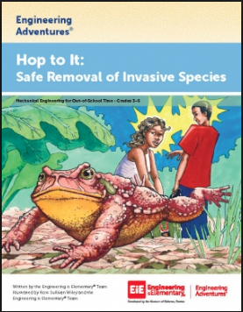
We have been busy for our first 6 weeks of programming! Students have started learning about invasive species in our fall engineering unit: “Hop to It” where students have to design a trap to catch the invasive Cane Toad in Australia and New Zealand.
Staff and students have been busy learning how to use our great new Osmo resources, as well participating in arts & crafts as well as outdoor games on Thursday
On October 23rd, students were able to travel to Hansel’s Orchard to pick apples, and on October 18th, they visited The Inn By the Sea!

Things to Look Forward To:

Meet our Staff!

Site Coordinator To Be Filled
E-mail: To come
207-650-0751

Teachers
Aidan Bowe
Carol call
Erica Indiano

Ed-Tech
Patty Brooks

21 Club Website: https://sopolwas.weebly.com/
- Contact Staff
- Download forms & other important information
- See what we are up to!

South Portland LWAS Director
Katy Bizier
kbizier@learningworks.me
181 Brackett St
Portland, ME 04102
207-775-0105 x 174

November 2nd: Lights On! Afterschool Event/First Friday
Join the LearningWorks After school family, along with our MECA Art students at a special celebration of Afterschool Programs, student displays, and other fun things! Free and open to the public! Event will be 4-6 PM at 380 Cumberland Ave in Portland.
November 7th: Field Trip to South Portland Public Library
Students will travel to the main branch of the South Portland Public Library on this day to learn how to get a library card, where books that may interest them are located in the library, and what other resources are available to students.

December 6th: Math/Literacy Night 4:15-5:15 PM
Join 21 Club students and staff on this evening to learn all about what math and literacy strategies we’ve been using this year, and fun games that you can play at home! You can then stay for Kaler’s Math/Literacy Night that will be right after ours!
Some Fun Picture Highlights
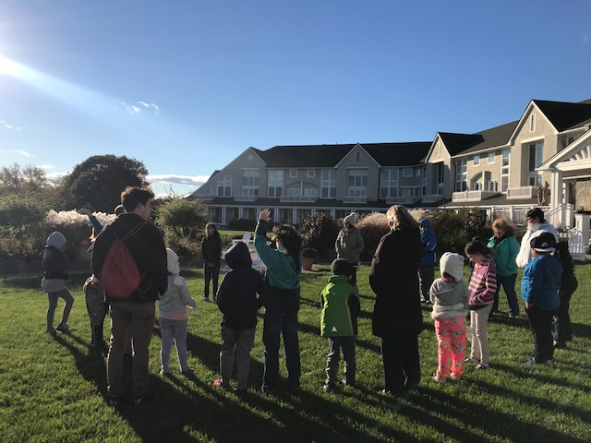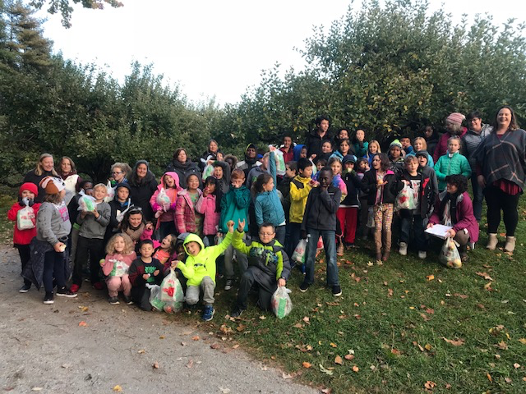
Kaler 21 Club at Inn By the Sea SoPo 21 Club at Hansels Orchard
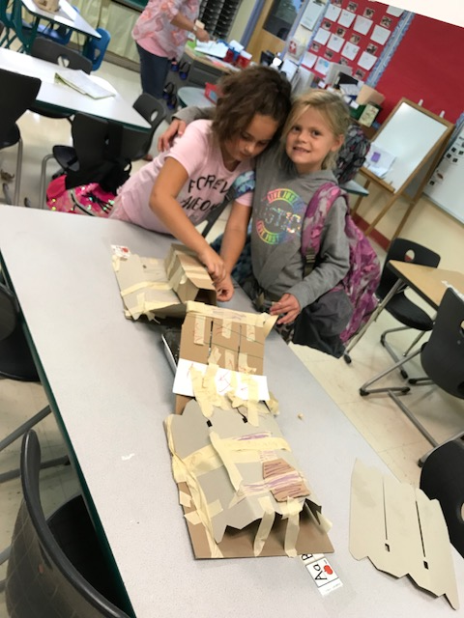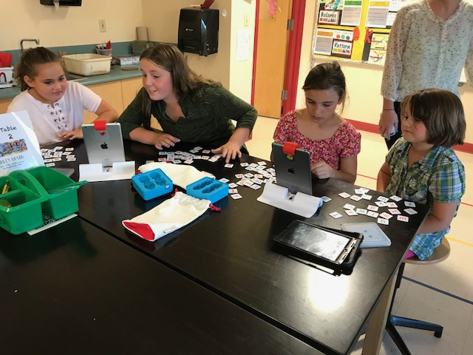
Students Build Bridges Osmo – Older teaching younger

