

Guide to

South Portland



LearningWorks AfterSchool and Summer Programs are free education programs that serve students in grades 2–5 at eleven schools in Biddeford, Portland, South Portland, and Waterboro. 21st Century Community Learning Center Funding and other charitable support makes LearningWorks programs available at no cost to families.

**Welcome!**



**LearningWorks After School and Summer Camp**

South Portland Director: Jen Belanger

(207) 775-0105 or [jbelanger@learningworks.me](mailto:jbelanger@learningworks.me)

Kaler Site Coordinator: Denise Dion-Sullivan

(207) 615-6235 or [denisesullivan@roadrunner.com](mailto:denisesullivan@roadrunner.com)

Skillin Site Coordinator: Diane Baker

(207) 615-6354 or [baker@cheverus.org](mailto:baker@cheverus.org)

Facebook Page: LearningWorks South Portland

Website: 21club.spsd.org



**Contact Information**



**Summer Hours After School Hours**

July 5th-August 5th2016 Sept. 19th –June 1st

Monday-Thursday Monday-Thursday

8:00am -12:00pm Dismissal at 5:30pm

(& Friday, Aug. 5 8am-12pm)

**Attendance Policy:**

Any student enrolled in LearningWorks will be expected to stay after school (and not allowed to take the regular bus home) unless both the school and LearningWorks have been otherwise notified by Parent/Guardian. Parents/Guardians must notify the school and LearningWorks prior to 2:00pm if your student is not attending that day.

We strongly encourage daily participation, but can also accommodate 2x or 3x per week participation, as long as there is a predictable schedule. Please discuss your needs with your site coordinator.

Program Hours & Attendance



**LearningWorks Behavior Expectations**

Guiding Philosophy

* Processing challenging behaviors with students, rather than punishing
* Caring and consistent limits, with reasonable and logical consequences
* Modeling behaviors

General Protocols (for more detail, ask your site coordinator)

Step 1: In- classroom interventions

Step 2: Site Coordinator Intervention

Step 3: Parent/Guardian and School involvement

LearningWorks and South Portland Expectations

* Be Safe
* Be Respectful
* Be Responsible
* Be Kind

Behavior Policy

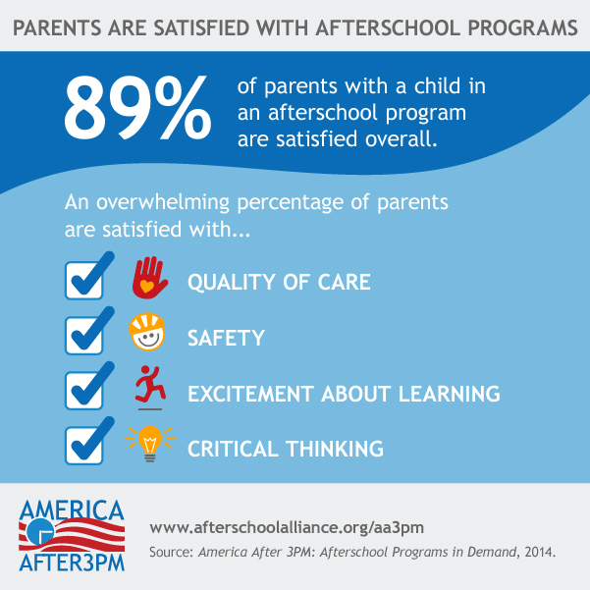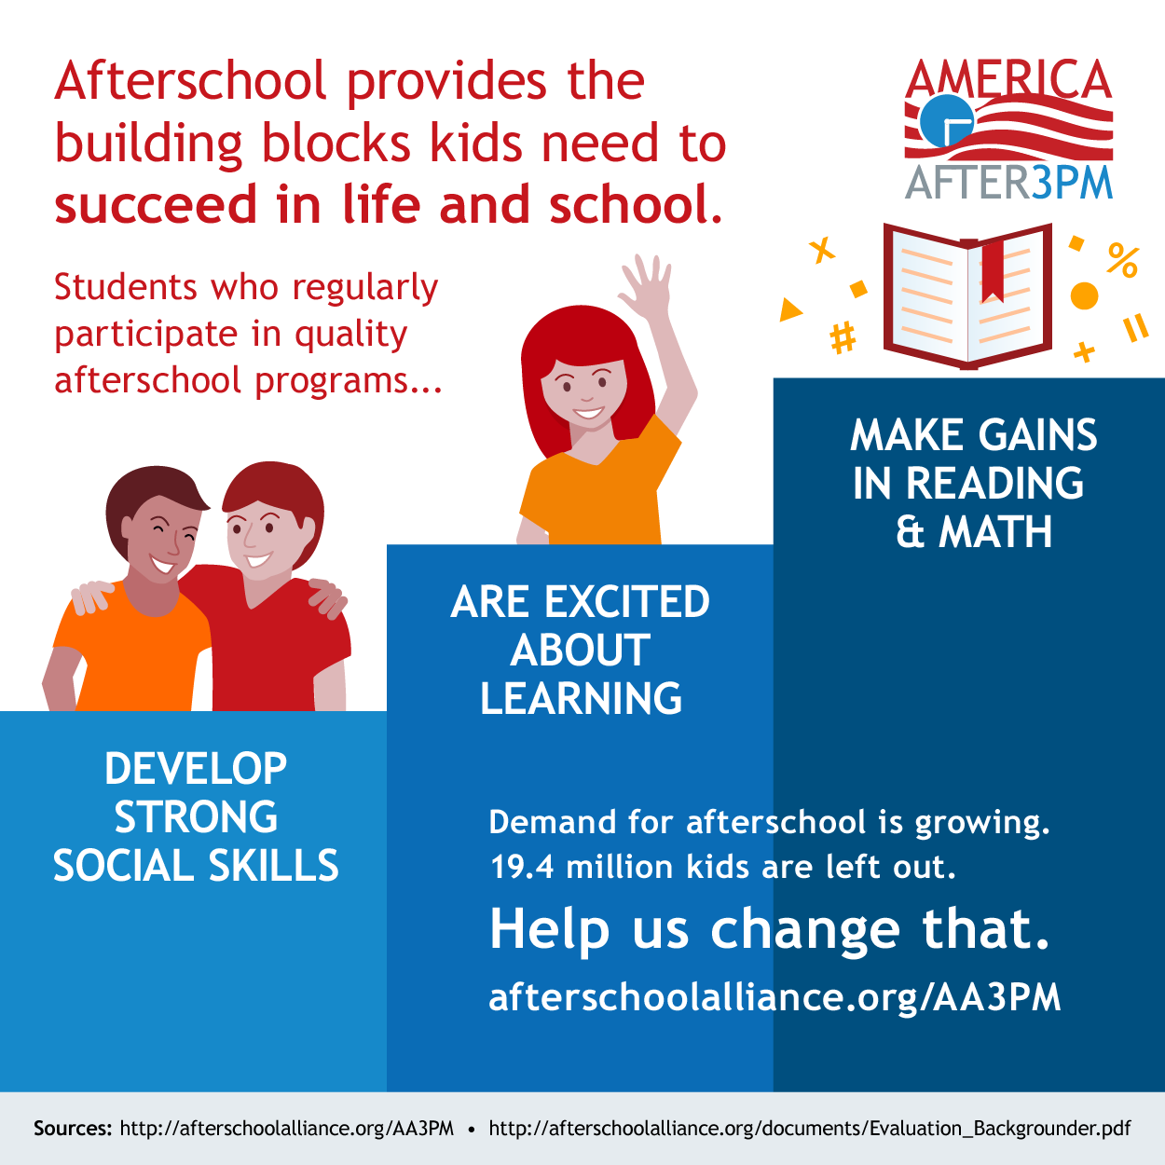



Why After School?



Transportation: Transportation is available year round on SPSD school buses. This includes transportation home during the school year, and transportation to and from during the summer.

Breakfast/Lunch & Snack: Breakfast and lunch is provided daily throughout the summer through SPSD Summer Food program. A daily snack is provided each day during the school year.

Enrichment Opportunities: 1x per week, our students have “Club Day,” where they choose activities that most interest them, including:

* Health and Wellness: yoga, sports, cooking and nutrition
* Arts and Cultural Enrichment: arts and crafts, painting, photography, dance
* Multi-Cultural Education: language and culture

STEM Curriculum: 2x per week, our students learn about STEM (Science, Technology, Engineering, and Math), primarily through the Boston Museum of Science’s *Engineering Adventures* curriculum. *Engineering Adventures* introduces children to the engineering design process and various fields of engineering. Each program “session” (see calendar) is a new *Engineering Adventures* unit.

There are many reasons to introduce children to engineering:

* Engineering fosters problem-solving, critical thinking, and collaboration skills.
* Engineering and technological literacy are necessary for the 21st century.

Literacy Curriculum: 1x per week, our students engage in literacy-focused activities designed by their teachers. This work directly helps in all areas during the school day.

Homework + LearningWorks: LearningWorks does not provide tutoring or homework-help services. However, we do allow students to complete homework during choice time and recess during the school year.

Program Offerings



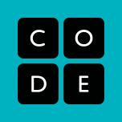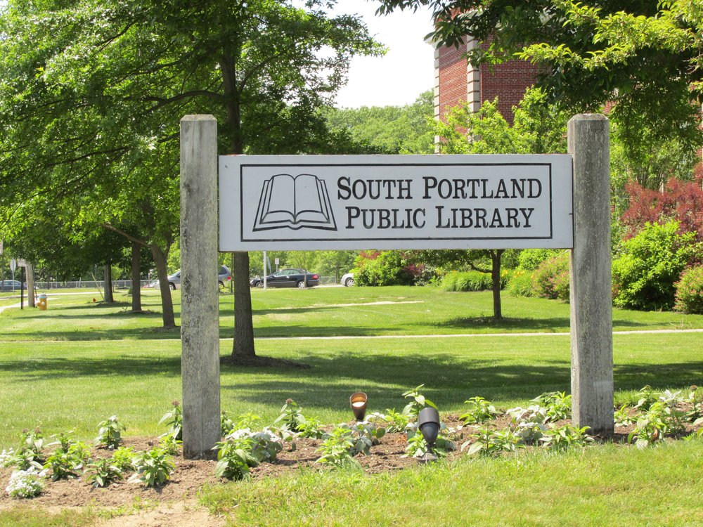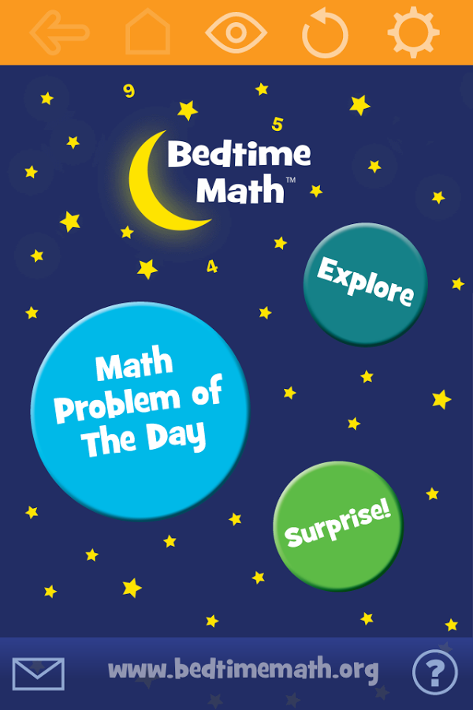

Code.org:

http://studio.code.org

Bedtime Math:

http://bedtimemath.org/heres-the-proof/

South Portland Public Library:

http://southportlandlibrary.com/programs-for-children/

More info on Boston Museum of Science’s engineering curricula:

http://www.eie.org/overview/engineering-children

Resources



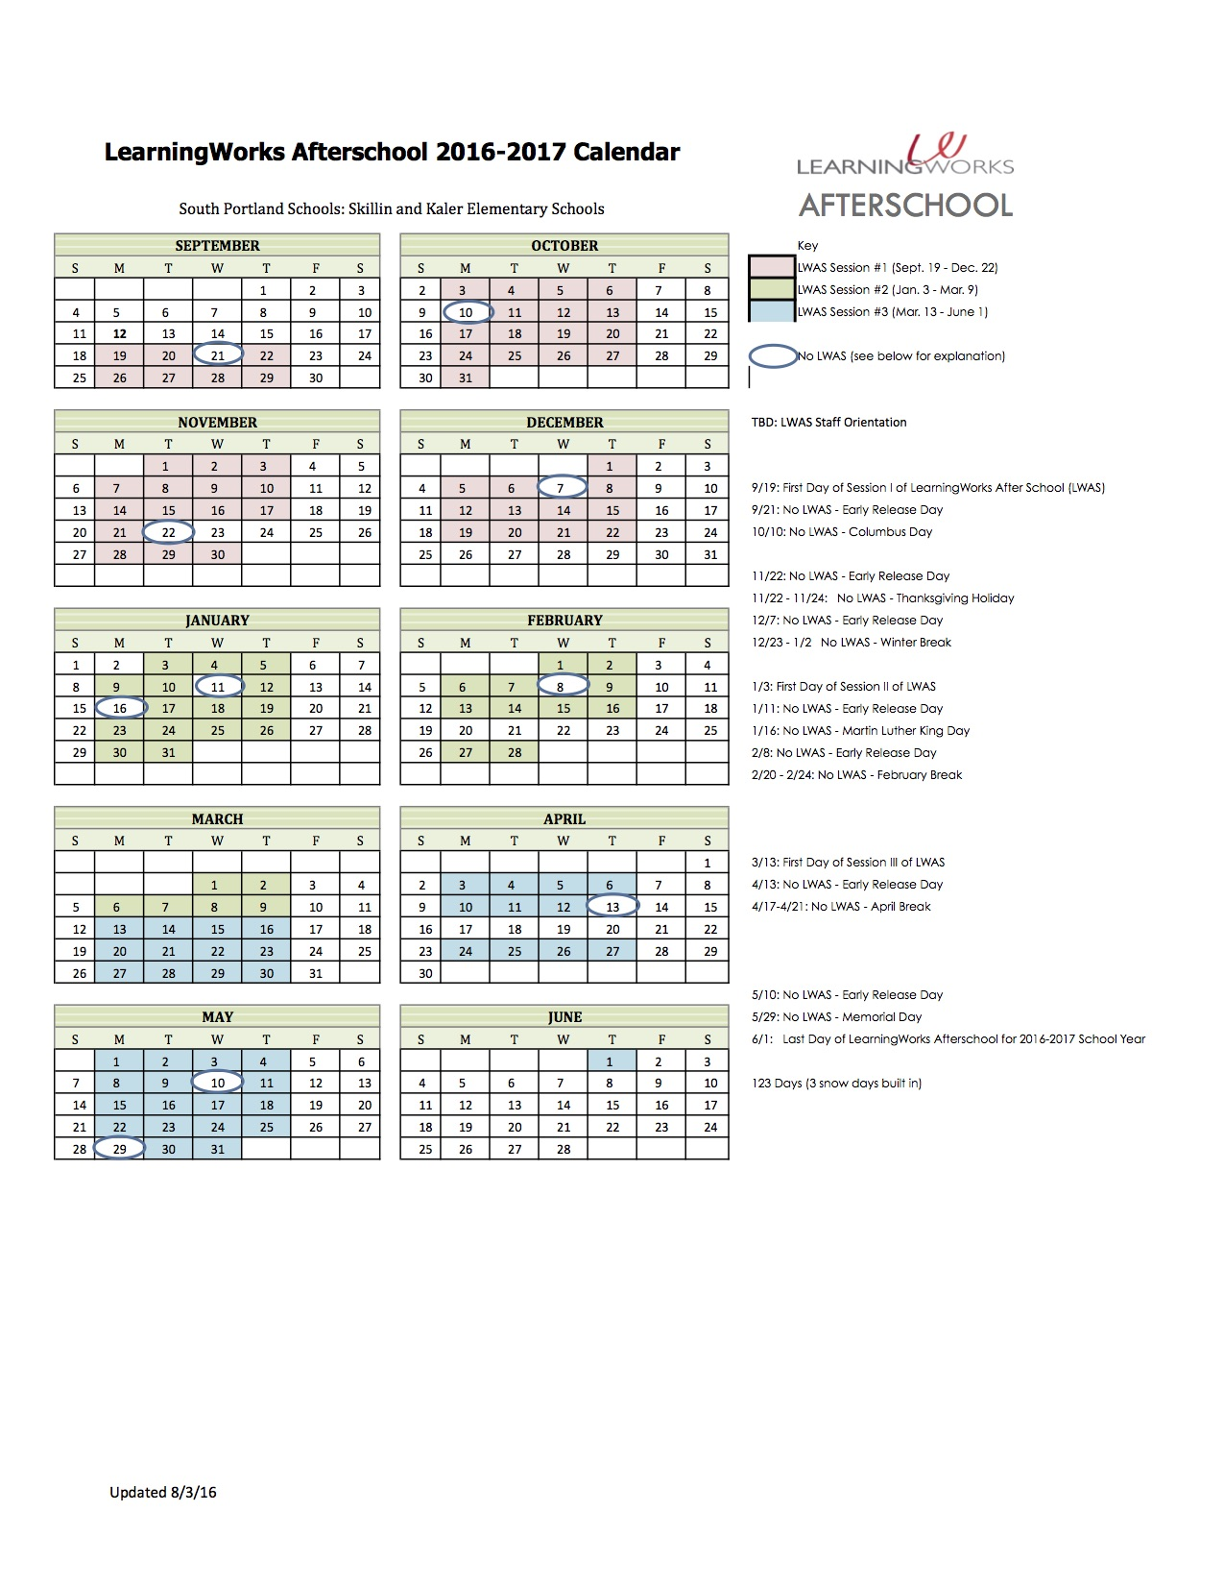

LearningWorks After School – South Portland

September 19, 2016 – June 1, 2017

Monday-Thursday

Does not run on Fridays, School Holidays, Early Release Days, or when school is cancelled

2016-2017 Calendar