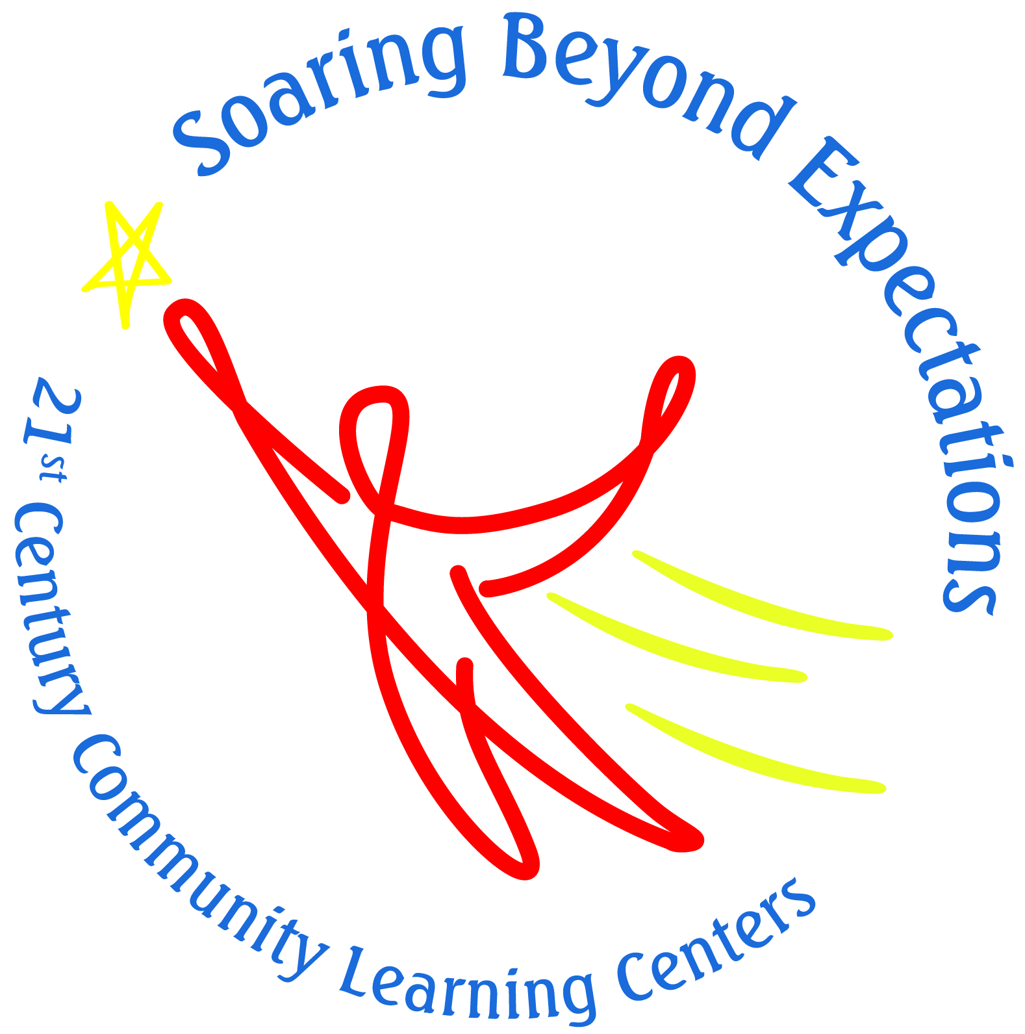 

**21 Club**



LearningWorks AfterSchool and Summer Programs are free educational opportunities that serve students in grades 2–5   
at eleven schools in Biddeford, Portland, South Portland, and Waterboro. 21st Century Community Learning Center Funding and other charitable support makes LearningWorks programs available at no cost to families.



**LearningWorks 21 Club Programs**

**Director, Katy Bizier:** [kbizier@learningworks.me](mailto:kbizier@learningworks.me)

Office: (207) 775-0105 x 174

**Skillin Site Coordinator, Diane Baker**

(207) 615-6354 or [dbaker@learningworks.me](mailto:dbaker@learningworks.me)

**Kaler Site Coordinator, Denise Dion**

(207) 650-0751 or ddion@learningworks.me

**Bus Department:** (207) 767-7714

**21 Club Website: <https://sopolwas.weebly.com>**

**FaceBook Page:** 21 Club - South Portland

LearningWorks Afterschool







**AfterSchool Hours**

September 17th – June 6th*

Monday – Thursday

3:05pm – 5:30pm   
*Tentative End Date  
(pending snow days)

**Attendance Policy**

When students attend regularly, we typically see increases in school administered math and reading assessment scores. Since space is limited and waiting lists are common,   
regular attendance is required. However, if a family has competing activities, it’s possible to modify the students’ schedule. Please contact us with any questions or concerns.





To be eligible for the program, students must have an academic need as well as the ability to control their behavior.

**Guiding Philosophy**

* Processing challenging behaviors with students, rather than punishing
* Caring and consistent limits, with reasonable and logical consequences
* Modeling behaviors

**General Protocols**

Step 1: In- classroom interventions

Step 2: Site Coordinator Intervention

Step 3: Parent involvement

**LearningWorks and District Expectations**

* Be Safe
* Be Respectful
* Be Responsible



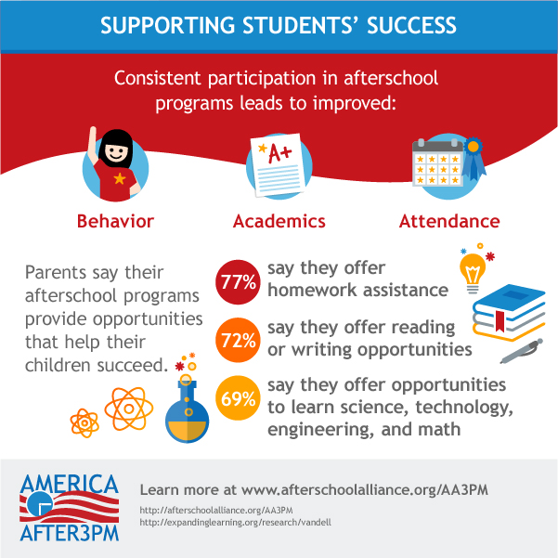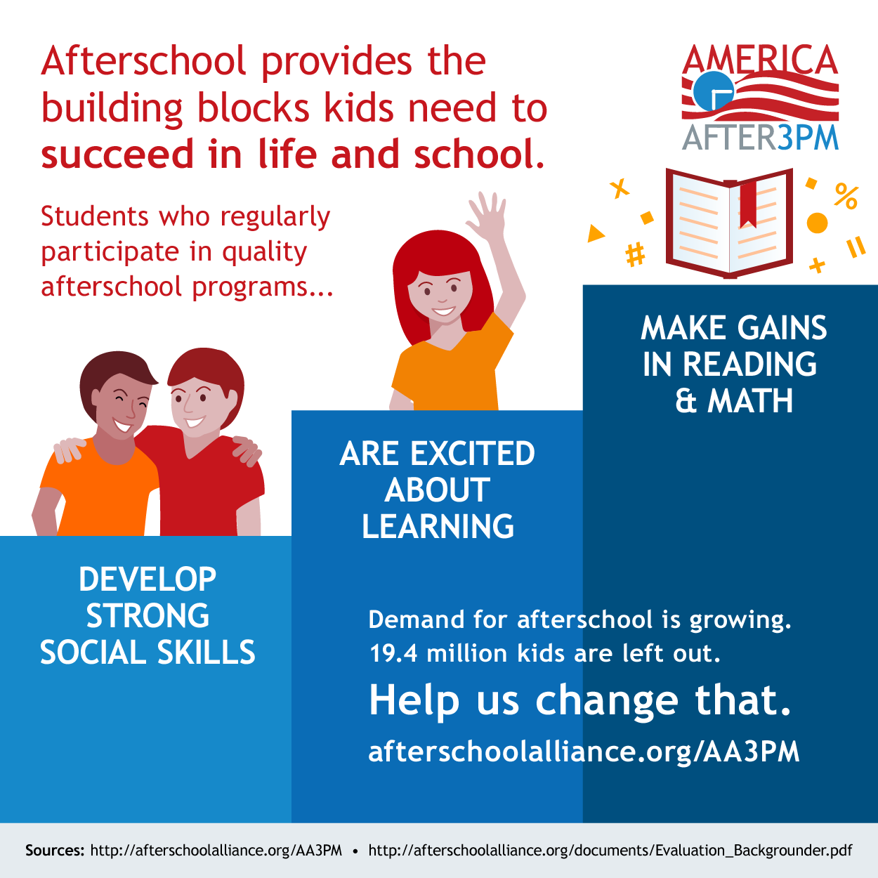

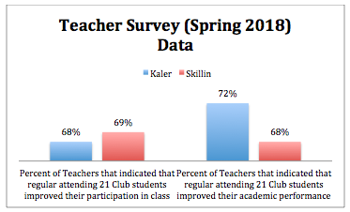



**Transportation:** Transportation is available year-round on district school buses. Transportation home during the school year, and transportation to and from during the summer.

**Snack:** A daily snack is provided each day during the school year. Our program follow Lets Go! 5210 Guidelines, and both Skillin and Kaler have been awarded Silver Level for their implementation of their guidelines

**Enrichment Opportunities:** Twice a week, students have club days where they choose activities that most interest them including: Health and Wellness, Arts and Cultural Enrichment, Multi-Cultural Education.

**STEM Curriculum:** Our STEM (Science, Technology, Engineering, and Math) focused curriculum follows the Boston Museum of Science: Engineering Adventures. Engineering Adventures is a curricular program that introduces children to the engineering design process and various fields of engineering.

There are many reasons to introduce children to engineering:

* Engineering projects reinforce topics children are learning in school.
* Engineering fosters problem-solving skills.
* Children are fascinated with building and with taking things apart to see how they work.
* Engineering and technological literacy are necessary for the 21st century.

**Homework + LearningWorks:** 21 Club/LearningWorks provides time each afternoon for students to complete homework and/or spend time reading. 21 Club/LearningWorks actively seeks out volunteers and opportunities, such as the Barbara Bush Teen Trendsetters to offer unique mentoring and tutoring help for our students.





